CS310 Final Project
Punctuation Dictionary
Source code: https://github.com/anhminhzing/-PunctuationDictionary
Anh Minh Duong, Andy Huang, Joyce Li
This project builds a dictionary of punctuation patterns found in sentences. Instead of focusing on the words, the program focuses on where punctuation appears in relation to the words in each sentence. Each punctuation mark is encoded after the ordinal position of the word it follows. The idea is to create a dictionary recording all punctuation across a set of books and how many of each occur. It focuses on how punctuation appears within sentences and is capable of recognizing punctuation positions relative to words. For example, the sentence “This, I believe, is a test.” becomes the pattern “1, 3, 6.” because punctuation appears after the 1st, 3rd, and 6th word.
The program will read the stored text files in our directory automatically and read it into memory. The text will then be divided into sentences by looking at the end of sentence’s punctuation like periods, question marks and exclamation to determine when the sentence ends. After the sentences are separated, the program scans each sentence and records where punctuation appears based on word position. The program also records summary statistics including: total files processed , total sentences processed ,total punctuation patterns found , and most common punctuation pattern . Finally, the dictionary and summary statistics are written to output files for future use.
The main data structure used in this project is an “unordered_map”. The key stores the punctuation pattern, and the value stores how many times that pattern appears. We used an unordered map because it allows fast insertion, lookup, and updates. When the program finds a punctuation pattern, it either adds it to the map or decreases its frequency count.
Our program has an unordered map which stores the key as the punctuation patterns (like , : ; . etc…) and value as the frequency count. We used an unordered map because of its fast insertion and lookup operation to make this program more efficient. Our time complexity for insertion is an average of O(1) because it will scan the text once and that also applies to our search and update operation since the text will be visited approximately once. Our time complexity of the program overall is O(n) because n is the total number of characters processed and n will differ based on shorter and longer text. The space complexity will be approximately O(n) since this program stores file contents, sentence vectors, and punctuation patterns. The memory usage will grow at a linear pattern as the input size increases.

The overall flow of the program is:
1. Read text files
2. Split text into sentences
3. Extract punctuation patterns
4. Store patterns in dictionary
5. Count frequencies
6. Save dictionary and summary files
The system was implemented in C++ using file processing, string manipulation, and hash map data structures. The program reads multiple text files from a directory and analyzes the punctuation patterns that appear in sentences. The implementation begins by scanning all .txt files using the C++ filesystem library. Each file is opened and its contents are read into memory for processing.
The program then separates the text into sentences using the splitSentences() function. A sentence is considered complete when punctuation such as ., ?, or ! is encountered. Additional logic was added to handle abbreviations such as Mr. or Dr. so that they are not incorrectly treated as sentence endings.
After sentence extraction, the getPunctuationPattern() function analyzes each sentence word by word. Every word is assigned an ordinal position starting from 1. Whenever punctuation appears, the program records the word position followed by the punctuation mark. The program also maintains summary statistics such as the total number of files processed, total sentences analyzed, total punctuation patterns detected, and the most frequently occurring pattern. Finally, all results are written into output files, including the punctuation dictionary and summary report, so the data can be reused later without reprocessing the original books.
The project was tested using multiple .txt files placed inside the demo folder. The program reads a total of three text files and processes 35 sentences.The program found 29 punctuation patterns with 21 unique punctuation patterns. The most common pattern was “5.”, which appeared 5 times. These results show that the program was able to read multiple files, identify punctuation patterns, and count their frequencies correctly.
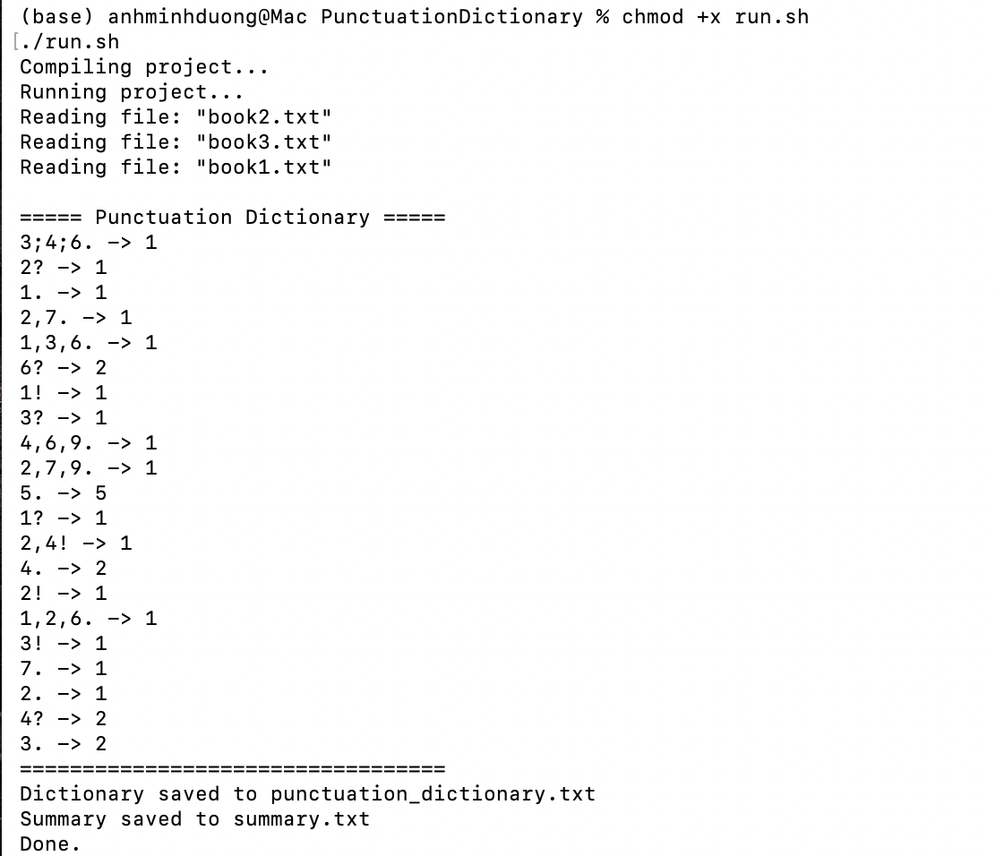
This screenshot shows the program compiling and running through “run.sh”. It reads the three sample demo files, creates punctuation patterns, and prints the punctuation dictionary in the terminal.
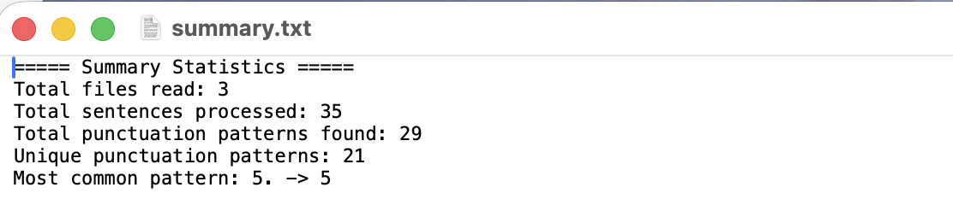
This screenshot shows the “summary.txt” output created by the program. It confirms that the program read 3 files, processed 35 sentences, found 29 punctuation patterns, and identified 21 unique punctuation patterns.

This is the result of implementing the actual books that we collect as txt files (in books folder).
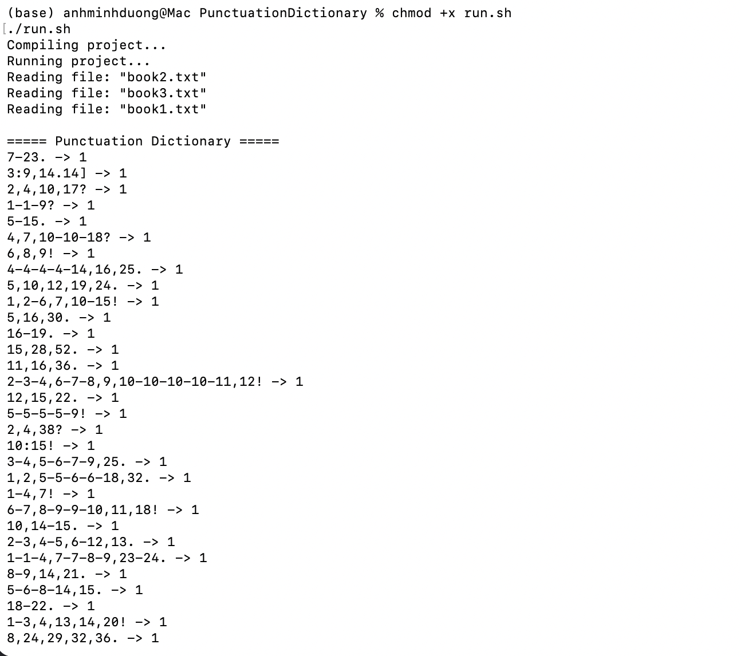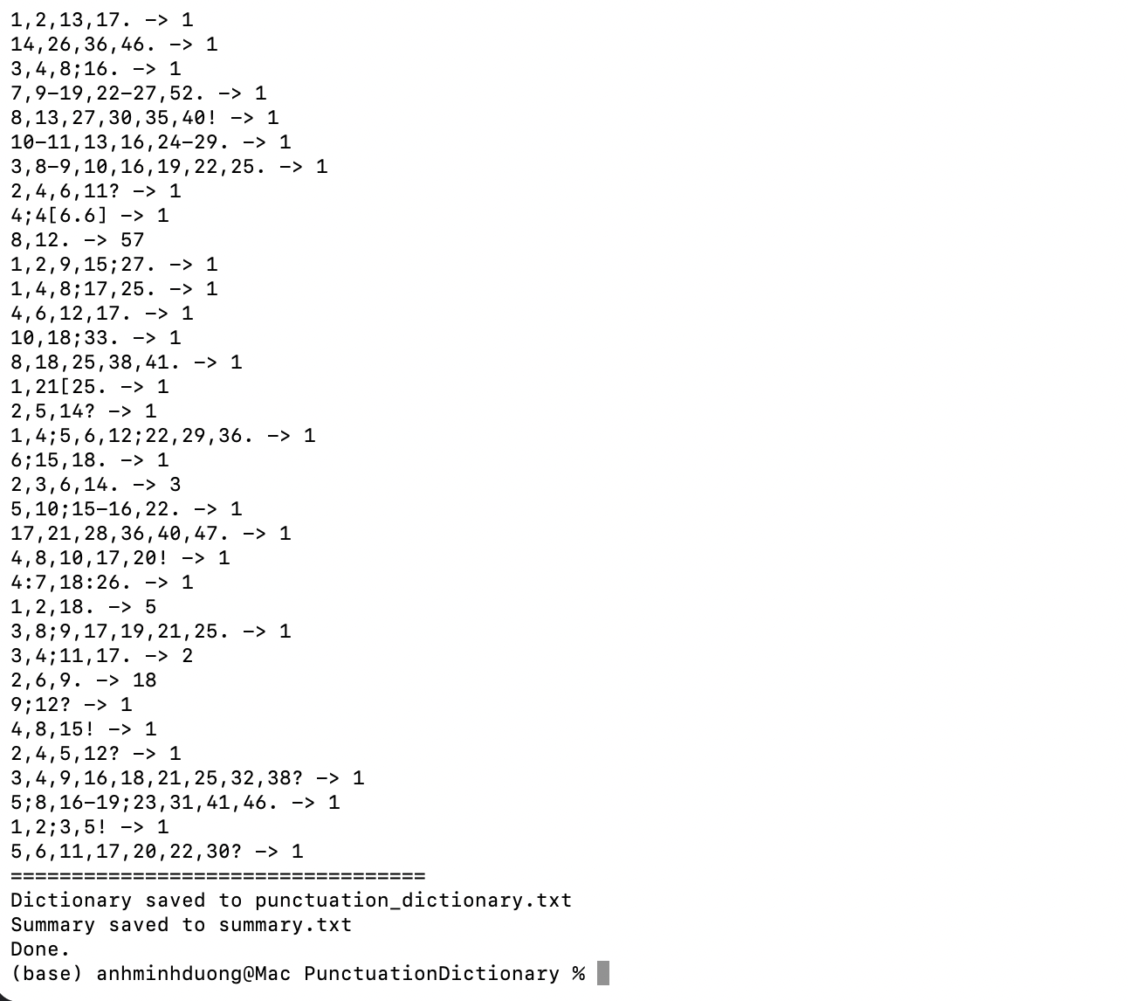
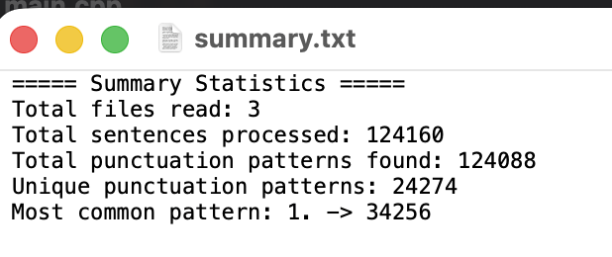
The results are what we expected from processing large literary texts. The most common pattern, 1., appears very frequently because books contain many short one-word sentences, dialogue responses, and stage directions such as “Farewell.” or “Madam.” Although the output contains a large number of unique punctuation patterns, this is actually a good sign because it shows the system successfully captured diverse sentence structures from real-world text. The large dataset provides rich and meaningful data for analyzing punctuation usage and testing dictionary compression performance.
A possible improvement would be to make sentence splitting much more accurate for cases like abbreviations, quotation marks, ellipses and apostrophe. Another improvement would be to sort the output by frequency so the most common punctuation patterns are easier to see.

